“The Masters of Future VII”
Traditional Art Design Contest/2019
GENEL KATILIM ŞARTLARI
- The contest organized to contribute to the development of traditional arts is named "Traditional Art Design Contest".
2-The fields of the contest will organize in four branches are as belows:
- Hüsn-i Hat
a- Thuluth- Nasikh Qıt’a
b- Jalî Talik
- Gilding
- Miniature
- Tile - Çini

3- The works to be submitted to the contest will be evaluted by the announced jury.
4- Principles related to the branches of contest are given in "Contest Specifications"
5- Members of the jury and their 1st degree relatives cannot participate in the contest. All amateur or professional artist and art students can participate. Students of the jury members may also participate in the contest.
6- Each artist can only participate in one branch and with one work.
7- There is no age and education level limitation to apply to the contest
8- Citizens of the Republic of Turkey and foreign nationalities may apply for the contest. Applications can also be made in the country and abroad.
9- The Participant acknowledges, declares and undertakes that the work it has sent to the contest is wholly owned by him/her and all permits are received. If the work belongs to someone else, the legal responsibility of copyright infringement shall belong to the participant. When detected, awards, titles and acquisitions that are awarded to those participants will be revoked. This does not mean that there will be a re-arrangement in the ranking of other participants.
10- The work to be submitted to the contest must not be exhibited or published before.
11- Works awarded in all branches (1. 2. 3. and 1 incentives) will be kept in the municipality collection. Non- awarded works will be returned to the participants after the exhibition.
12- Only two creations will be selected for exhibition from each branch.
13- In the event that no work is awarded by the jury, the prizes in that area shall be canceled.
14- Zeytinburnu Municipality is entitled to use the visuals of the works submitted to the contest, information about the works or artists on the books, catalogs, brochures, posters etc. which may be directly or indirectly related to the contest or irrespective of the fact that whether they have been awarded or not, or on its website, internet and press promotions for the purpose of publicity. No royalties will be paid to the artist regarding this.
15- The Municipality of Zeytinburnu has the right to exhibit the works submitted to the contest, the visuals of the works and the related information.
16- Zeytinburnu Municipality shall not be held responsible for the losses and damages arising from submissions.
17- No introductory sign such as name, signature, seal, etc. shall be used in any part of the work to be submitted to the contest. A number consisting of 3 letters and 4 digits will be written on the back upper right-hand corner of the work. The artist should write the paper files containing his name, surname, e-mail, his website, if any, telephone number, mobile number, correspondence address, date of birth, the field in which he audited and other information and then put it in an envelope and close it, then will write the same symbol on the back of envelope with indelible ink. The artist will also deliver this envelope with his creation.
18- Prize money will be given to the works present in the first top three and which received incentives. Works entitled to exhibition rights will not receive cash prizes.
19- All selection stages of the competition will be photographed.
20- Any information, announcements and respective results related to the contest will be available at www.geleceginustalari.ist.
21- All participants - whether or not awarded - will receive a certificate of participation.
22- Any artist who has applied to this contest and is accepted to compete are deemed to have accepted all conditions of the contest.
23- Address of Application
Zeytinburnu Belediyesi

Zeytinburnu Kültür ve Sanat Merkezi
Semiha Şakir Caddesi 15 Temmuz Meydanı
Zeytinburnu/İSTANBUL

Telefon:+90 212 413 11 11 / 3608
Telephone:

ŞARTNAME
SPECIFICATION OF HÜSN-İ HAT(Calligraphy)
1- Hüsn- i Hat contest will be organized in four categories.
1- Thuluth- Nasikh Qıt’a
2- Jalî Talik
2- The works participating to the competition shall have original piling and line designs.
3- Manuscripts will be written in black ink, light colored paper, in accordance with sized paper suitable for calligraphy. The paper should not be too thin or transparent.
4- The width of the pen mouth shall not be larger than between 3-3.5 mm for Thuluth and between 1-1.5 mm for Nasikh at Thuluth- Nasikh Qıt’as; and not larger than between 6-8mm for text of Jali Talik.
5- The text will be written in two lines at calligraphy of Jali Talik .
6- There shall be no ornaments and no signatures on the script; the place or line for the signature will be empty.
7- The script papers shall be delivered without framing, without being affixed to any material, between two cardboard boxes, so as not to be broken.
8- Works that do not comply with the general conditions of participation and the above conditions, those with spelling errors and artifacts not delivered on time shall be excluded from the competition.
9- One of the following texts will be selected as script. Any additions other than text will not be made.

TEXTS TO BE WRITTEN
1- Thuluth text at Thuluth- Nasikh Qıt’as:

وَلَا تَقُولُوا لِمَنْ يُقْتَلُ ف۪ي سَب۪يلِ اللّٰهِ اَمْوَاتٌ بَلْ اَحْيَاۤءٌ وَلٰكِنْ لَا تَشْعُرُونَ

“And say not of those who are slain in the way of Allah: "They are dead." Nay, they are living, though ye perceive (it) not. “(Bakara 2/154)

2- Nasikh text at Thuluth- Nasikh Qıt’as:

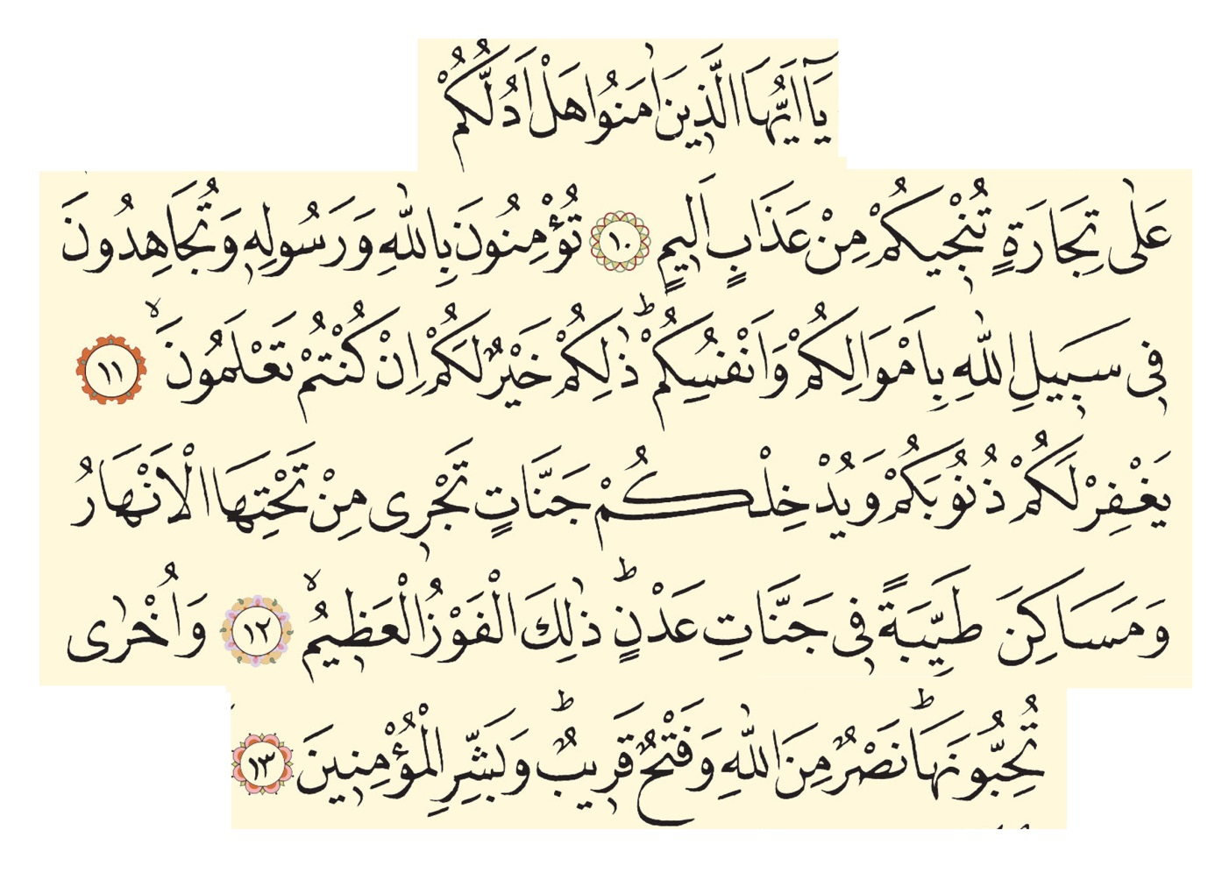

O You who believe! Shall I guide you to a commerce that will save you from a painful torment. That you believe in Allah and His Messenger(Muhammad SAV), and that you strive hard and fight in the Cause of Allah with your wealth and your lives, that will be better for you, if you but know! (If you do so) He will forgive you your sins, and admit you into Gardens under which rivers flow, and pleasant dwelling in Gardens of 'Adn - Eternity ['Adn (Edn) Paradise], that is indeed the great success. And also (He will give you) another (blessing) which you love, help from Allah (against your enemies) and a near victory. And give glad tidings (O Muhammad SAV.) to the believers. (Saff 61/10-13)

3- Jali Talik text

ای شهید اوغلی شهیدایستمه بندن مقبر
سکا اغوشنی اچمش طورویورپیغمبر
عاکف

SPECIFICATION OF GILDING
1-Gilding shall be made within the dimensions of 35 x 50 cm. Works can be sent in smaller sizes.

2-Calligraphy or miniature will not be used in Gilding.

3- Paper, gold and water based paints will be used in the works.

4- On the condition that you should use gilding mostly on your creations, Halkari techniques also can be used.

5-In the compositions, original and different designs can be created by adhering to the classical Gilding rules.

6- The work will be sent unframed and matted.

7- The subject is unconstrained
SPECIFICATION OF MINIATURE
1-Miniature shall be made within 35 x 50 cm paper measurements. Works can be sent in smaller sizes within these dimensions.
2-If there is an overflow in the work, it must stay within the measure.
3- The subjects of miniature are Martyrdom and Shahada.
4- The work will be sent unframed and matted.
SPECIFICATION OF TILE ART
1- The original designs and practices used in the traditional tile techniques and styles known in the history of Turkish tile art will be accepted.
2- Works can be both designed by using ceramic tiles and in three dimensional forms.
3- The longest side, width or height of the works must not exceed 80 cm.
4- The subject is unconstrained.
5- Works will be delivered in a completed form.

THE MEMBERS OF JURY
Calligraphy
Ali Toy
Cevad Huran
Davud Bektaş
Fuat Başar
Savaş Çevik
Süleyman Berk
Tahsin Kurt

Ginding
Abdullah Oğuzhanoğlu
Berna Kervan Karabulut
Emel Türkmen
Nülifer Kurfeyz
Selim Sağlam

Miniature
Esra Oğuzhanoğlu
Feyza Şen
Gaye Özen
Özcan Özcan
Zaliha Peçe

Tıle Art
Levent Kum
Mehmet Gürsoy
Özkan Tokaç
Serap Ereğli
Timur Bilir

COMPETITION SCHEDULE
The deadline for submit is Sunday, March 08, 2020, until 17.00

Submission Deadlines For Creations
18 Şubat - 08 Mart 2020
Evaluation Date of Selection Committee
09- 11 Mart 2020
Announcement of Results
13 Mart 2020 Cuma
Award Ceremony
5 Nisan 2020 Cumartesi
Exhibition Dates
5 Nisan – 14 Nisan 2020
AWARDS
- 20.000 TL
- 15.000 TL
- 10.000 TL
Incentive Awards
- 7.500 TL

